Abnormal Cellular Biology
Name of Student
Name of Institution
Date
In all living things the basic unit is a cell, with constituent molecules that define the characteristics of its hosting organism. The cell is an organism complete by itself with specialized functions which they may accrue and become more complex as the cell matures. The study of its functions and properties is termed as cellular biology. The study encompasses basic constitution of the cell, mode and ease of replication, interaction of constituent parts, and the relationships of the three aspects with regards to the environments. The cells cooperate in part or in function with other cells with similar specialized objectives, thus becoming building blocks for organs, tissues, and organisms. The three are classified as multi-cellular organisms which are defined as either constituents of plant or animal life. The cells in animals are eukaryotic, surrounded by a plasma membrane, which bind vital organelles and the electrons, and the nucleus.
The cells in animals and humans are of different sizes, each exhibiting different characteristics. The sizes range from 1 micrometer to 100 whose visibility is dependent upon the use of a microscope. The human body is constituted of trillion of cells, in distinctive varieties that sum up an approximate of 210 differentiated cells. The membrane binds the nucleus and other organelles, and the latter are fundamental to the functioning of the cell. The cell lacks a cell wall which is attributed as the cause of their irregular shape and size, and constitute of a variety of structures like lysosomes (Parodi, et al., 2013), flagella, cilia, and centrioles. The cell is constituted of a number of parts, each varying in characteristics and function. Since the constitution of an organism is largely dependent on the cell any defect or de-function within a cell, affects the entire body causing a myriad of chain reactions to substitute the function. The diagram below shows the different parts of an animal cell.
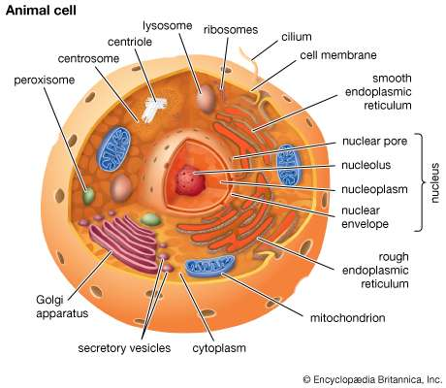
When the cells grow uncharacteristic to their functions or constitution in the body, they are regarded to as tumors. To qualify, the cells are defined by an abnormal growth or lump. The growth may be contained within the membrane and may not. Those that are contained are classified as normal tumors which lack the capability to grow uncontrollably. The abnormality in the cells is as a result of misstep in the process resulting in unusual growth which forms a lump, thus classified as benign tumors. Those that are cancerous and whose growth can spread are termed as malignant. A pathologist is a critical determinant of the abnormality and its classification by analysis of cells extracted from the body with a biopsy machine.
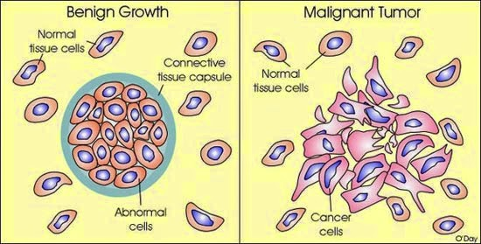
The benign tumors lack the capability to metastasize and invade any nearby tissues, and are thus classified as non-cancerous. The major worry a benign tumor can cause to the victim is situation where the unusual growth is pressing against a fundamental tissue, nerves, or blood bringing about near fatal damage. The uncontrollable growth of benign tumors may be unlimited at times, and their subsequent growth may add up to pounds, blocking channels and crowding the normal structure formation. To remove benign tumors, surgery is critical, and once removed, these types of tumors rarely recur. Those benign tumors that recur are restricted to the same spot they were surgically removed from. Some benign tumors are regarded to as pre-cancerous, and are thus surgically removed to prevent them from developing into malignant tumors.
The cells within this clarification mostly grow slowly and tend not to spread to neighboring organs or tissues. The significant difference between spread and invasion is the factor of infection versus damage, of which benign tumors are significantly characterized with the latter. These tumors have a tendency of forming clear boundaries within the body, and thus they lack metastasizing capabilities. When viewed under the microscope, the DNA of these tumors, shape and chromosomes are classified as normal by the pathologist. Other than the pheochromocytomas that are secreted in the adrenal gland, benign tumors possess no capabilities of hormonal secretion or secretion of other substances within the bodily system. The benign tumors are treated only in cases where they are proven to be life threatening, otherwise treatment is not a necessity. Once surgically removed, benign tumors do not require additional treatment.
Those cells that grow uncontrollably, not restricted by the cell membrane are known as malignant, and they have the capability to spread to other cells, tissues and organs. The term malignancy is associated with dangerous health conditions. This danger presented by the term is because it is not only linked to cancer, malignancy is also adopted to describe ominous effects of medical and psychological conditions. The malignant tumors are cancerous and spread by movement through the nymph nodes or bloodstream. This movement leads to infections of other regions of the body, and the process of infection is called metastasis. The cancer cells can occur and form in any part of the body, effectively spreading from a single point of origin. The tumors are also defined by their rapid rate of growth and spread (Klijn, et al., 2015). When the malignant tumor is formed from the granular structures from the epithelial tissues in the skin, they are termed as adenocarcinoma. The terms refer to the cancer that begins from the glands in the cells to the internal linings of the organ of the body.
The constitution and infection constituent of malignant tumors often invade the basal membrane surrounding the healthy tissue prior to infection. Other than the bloodstream and lymphatic systems, the cancerous tumors can spread through sending ‘fingers’ to neighboring healthy tissue, though they rarely adopt this methodology. The resulting effects of these tumors are fatal and their constituent characteristics require invasive treatment procedures. Other than surgical operations, the aggressive treatment regimens that may be adopted in such cases involve immunotherapy medications, chemotherapy, and radiation. Malignant tumors create a significant threat of recurring after being surgically removed, and their recurrence is not limited to the original point of extraction. The malignant tumors are observed as large black masses which are an illustration of their uncharacteristic nucleus containing abnormal DNA and chromosomes. The cancerous tumors have the capability to secrete substances into the body which is realized by the person as fatigue and weight loss, also known as paraneoplastic syndrome. Paraneoplastic syndrome. Heterogenicity within the cell analysis of a cancerous patient define the evidence of a range of normal, precancerous and cancerous cells, differing in appearance and positioning, within the tumor specimen.
Diagnosis of the type of tumor requires a sample presented to the pathologists. On confirmation the tumor is benign, the doctor will conduct further tests for assurety and to ensure to the patient that the tumor is not cancerous. The doctor will then analyze the type of tumor detected and advice on the next cause of action between observation and removal. Those patients worried about their cosmetic health are advised to commit to surgical extraction. In the case that the pharmacologist detects signs of malignant tumors, the patient is referred to an oncologist. The doctor assigned to the case will thus carry out further testing for the determination of what stage of cancer the patient is in, and devise a treatment protocol determined by the stage and location of the tumor. The determination of the stage of cancer will employ the use of imaging tests, surgery, or biopsies, or any form of combination of the three (Eldridge, 2019). Upon determination of stage, it is fundamental that therapy be adopted to limit the growth of the tumors. In the early stages, the tumors have not spread much, but later stages witness significant spread throughout the body with a central point. Consultations are critical components of treatment and psychological approach after either of the two cases is determined.

References
Eldridge, L. M. (2019, January 8). Malignant: Medical Definition and Characteristics. Understanding Malignant Tumors, Cells, and Medical Conditions. Retrieved from verywellhealth: https://www.verywellhealth.com/malignant-definition-and-characteristics-2249124
Klijn, C., Durinck, S., Stawiski, E. W., Haverty, P. M., Jiang, Z., Liu, H., . . . Pau, G. (2015, December). "A comprehensive transcriptional portrait of human cancer cell lines.". Nature biotechnology, 33(3), 306.
Parodi, A., Quattrochi, N., Van De Ven, A. L., Chiappini, C., Evangelopoulos, M., Martinez, J. O., . . . Isenhart, L. (2013). "Synthetic nanoparticles functionalized with biomimetic leukocyte membranes possess cell-like functions.". Nature nanotechnology, 8(1), 61.

